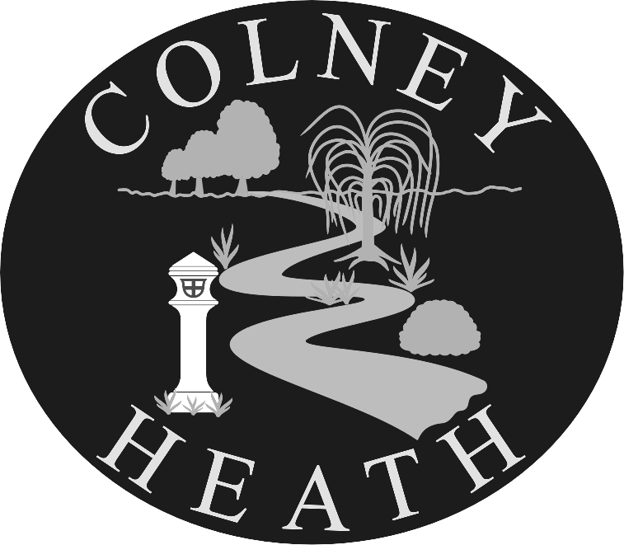

COLNEY HEATH SCHOOL & NURSERY

High Street, Colney Heath, St. Albans, Herts. AL4 0NP
Telephone: 01727 823898

Fax: 01727 827085

E-mail: admin@colneyheath.herts.sch.uk

Website: www.colneyheath.herts.sch.uk

Headteacher: Mr. P. Rose



AGENDA
ANNUAL GENERAL MEETING – 19TH October 2017 7.30 pm

1. Welcome from Current Chair

2. Apologies

3. Acceptance of previous AGM

4. Matters arising from the previous AGM

5. Head Teacher’s Report

6. Chairman’s Report

7. Treasurer’s Report

8. Appoint Auditor/Book keeper for the next financial year

9. Election of Officers

10. Monthly PTA meeting

