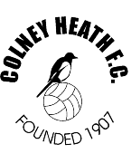

Are you looking for a local football club for your son/daughter, which is FA Charter Standard?

Are you interested in running a team and being the manager?

Do you want to be a qualified football coach?

**WE CAN HELP.**

Colney Heath Youth FC are looking to expand mini soccer within the club and are looking for volunteers to run the following age groups

Under 7s – school year 2

Under 8s – school year 3

Under 9s – school year 4

Under 10s – school year 5

This will be for season 2019/20.

Interested? – get in touch with us.

[thecolonel1969@outlook.com](mailto:thecolonel1969@outlook.com) or [rs@colneyheathfc.com](mailto:rs@colneyheathfc.com)