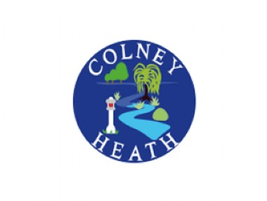**Cost of the School year at Colney Heath**

|  |  |  |
| --- | --- | --- |
| Autumn Term    Uniform.  How we can help  We have a bank of previously loved uniform that is in good condition. Please ask at the office if you need help with items.  Apart from the Colney Heath jumpers and cardigans, most uniform can be obtained from supermarkets.    Trips/events coming up this term….   * Year 3 Trip to Celtic Harmony (Stone Age topic)   Approx cost:  £27   * Year 4 British Museum   (Egyptian Workshop)  Approx cost:  £18.25   * Year 5 History off the Page   (Saxons/Tudors)   * Henry Moore Visit to Perry Green   (Art)  Approx cost for both:  £27.50   * Year 6 History off the Page   (Saxons/Tudors)   * Henry Moore Visit to Perry Green   (Art)   * Crucial Crew (PSHE/life skills)   Approx cost for all three:  £40  Clubs    Currently the clubs available are available on our website  (See below or see the office)  Children In Need Donation  £1  Christmas  Non uniform day  Christmas fair contributions  Christmas party food | Spring Term    Trips/events coming up this term…..   * Nursery/Reception   Aldenham Country Park  £22   * Year 1 National Gallery (Art topic Colour workshop)   Approx cost:  £15   * Year 2 Mill Green (Great Fire of London workshop)   Approx cost:  £28   * Year 3 Bedford Faith Tour   (RE)  Approx cost:  £23   * Year 4 National Portrait Gallery (Art topic)   Approx cost:  £15    Year 5 Science Museum  (Space topic)  Approx cost:  £20   * Year 6 Natural History museum (Evolution workshop)   Approx cost:  £20 | Summer Term    Trips/events coming up this term…..   * Nursery/Reception   (Zoo trip)  Approx cost:  £27   * Year 1 Tower of London (Who lives in the tower workshop)   Approx cost:  £35   * Year 1 Seaside (History)   Approx cost:  £20   * Year 2 Knebworth House   (Plants)  Approx cost:  £30   * Year 3 Leavesden Country Park (Sculpture trail)   Approx cost:  £12   * Year 4 Verulamium/Cathedral (History/RE)   Approx cost:  £25   * Year 4   2 Day Residential Trip to Cherry Green Trees including climbing/HYMB  (Herts Young Mariners Base)  Approx cost:   * Year 5 Living Rainforest   (Adaptations)  Approx cost:  £35   * Year 5 Residential Trip   Approx cost:   * Year 6 Residential Trip   Approx cost:  TBC   * Year 6 seaside   Approx cost:  £20  Donations to summer fair    We generally ask for bottles and sweets for the stalls.  The money from the summer fair helps to fund the school trips.  Race for Life contribution? |
|  | | |