**Dear Year 1 Parents and Carers,**

Literacy In Literacy we will be reading the book called “Out of the Blue “ and will be working really hard on remembering our capital letters at the beginning of a sentence, full stops at the end of a sentence and finger spaces.

We will be writing lists, describing characters, labelling pictures, writing letters, creating little booklets.

To in still a love of writing and help your child at home you can get them to write your shopping list, little notes to you or friends, label things in your room and make cards and booklets.

Phonics. In year 1 we have daily phonics lessons.

I will give you a list with the terms sounds we will be learning. Could you please practice the sounds at home, this will really help in your children`s learning.

Here is a link to some phonics games to play.

[Phonics Play - Phase 4 Resources](https://www.phonicsplay.co.uk/resources/phase/4)

Choose Phase 3 and 4 first then try phase 5 when you child is ready.

Reading We have regular reading in year 1 individually and in groups. We ask questions and discuss the text and talk about the pictures. Reading is the key to literacy and you can play a big part in helping your child by sharing their book with them at home. Also sharing other books and reading to your child and discussing their book ask questions EG. What do you think might happen ? Why do you think he did that ? etc..

In Maths we are learning about the conservation of number and being able to recognise patters of objects.

We will be working hard on using a tens frame to help in our maths calculations and knowing our number bonds to 10.

We will be using positional language (on, next to, beside etc)

Ordinal numbers ( 1st, 2nd ,3rd…) and of course counting and our number formation.

To help your child you can count with them as much as you can. Make guesses of how many strawberries in the bowl then count. Count the stirs as you walk up them, say one more than a number and one less. EG 1 more than 10 , 1 less than 7. All these fun games really do help your child in their learning.

Here are some links to maths games.

There are a lot more really fun games ideas if you have a look on ITC games.

<https://ictgames.com/mobilePage/tenFrame/index.html> Using a tens frame

<https://ictgames.com/saveTheWhale/index.html> Number bonds to 10 game

[Pinbun Panda - Subitise numbers to 10 (ictgames.com)](https://ictgames.com/mobilePage/beanBunPanda/index.html)

Counting and subitising

[Bee Hive - More & Less (ictgames.com)](https://ictgames.com/mobilePage/beeMoreOrLess/index.html)

One less one more.

Science In Science we will be finding out about the `4 Seasons.` and what weather we can expect! We will be recapping months of the year in relation to the seasons.

Later on in the term we will move onto a topic on `Materials.` and finding out the properties of different materials.

Art In Art we are exploring the sculpture of

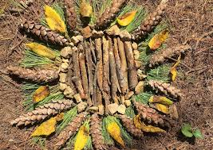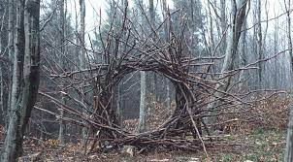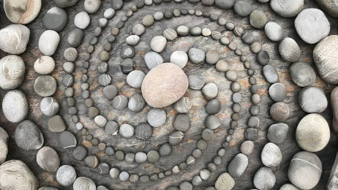Andy Goldsworthy. We will be creating our own `Land Art` using natural objects and clay to create our own sculpture.

History In History we will be exploring “Toys from the Past”

We will be finding out about what toys our parents and grand parents played with and what they were made of. We will be creating timelines and finding out if about toys beyond our living memory and our parents and Grandparents living memory.

D&T We will be making our own moving pictures using levers, paper, split pins and learning joining techniques.

Music In Music we will be following our scheme called Charanga and listen to a variety of different songs which we will find the pulse of. We will learn the song `Hey You ` and perform it.

PHSE In PHSE we are following our scheme called Jigsaw. This term is all about `Being me in my world`

RE In RE we will be finding out about how Harvest is celebrated by different religions and moving onto Festivals of light.

PE In PE our units are health and wellbeing and tag games.

We will be having PE lessons on Tuesday and Thursday . It is essential that your child has a PE kit for this lesson. Please ensure your child has a named PE kit in a named PE bag, with plimsols and trainers for outside PE.

Please come and see me if you have any questions.

Thank you.

Mrs Dowling

.