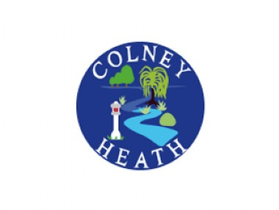
PTA Meeting Minutes
11th January 2022

- Welcome

- Present – Mr Rose, Claire Woolman, Alison Fordham, Jonah Sutch, Alex May, Beth Stern, Caroline Briggs, Nick Cannons, Kate Jarrett, Kayleigh Arodu, Terri Dimetriou, Sam Brandish, Denia Oliveira, Charlotte Flanagan.

- Apologies – Sain Bull

- Treasurers Report – Full report on website

- 200 Club Draw – To be drawn in the office and numbers confirmed at next meeting. Renewal is coming up and discussions required to identify new members.

- Event Planning
Comedy night on 18th March, all performers booked. Alcohol License to be issued.
Juniors Film night, 21st January, New Home Alone film (9+) permission to be requested on gateway. Dan Stern to collect Pizza’s from Domino’s Hatfield. Natalie West to set up the film at school. Volunteers – Alison Fordham, Claire Woolman, Natalie West, Dan Stern, Beth Stern. Confirm if film license needed.
Infants Film night 4th Feb, Luca. Volunteers to be confirmed nearer the time. Kate Jarrett offered.
Disco on 25th February – Sam Brandish organising
- Communication – Possible PTA Facebook page. PTA introduction letter to be issued on Friday 14th March.

- Christmas cards – Profit of £339.60 collected and has been spent on Food Technology equipment to use in classrooms.

- The Next PTA Meeting – 3rd March

- A.O.B

