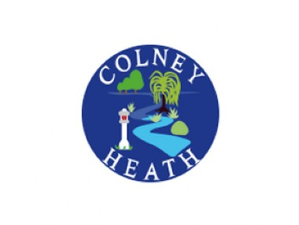
PTA Meeting Minutes
3rd March 2022

- Welcome

- Present – Mr Rose, Claire Woolman, Alison Fordham, Jonah Sutch, Alex May, Sam Brandish, Natalie West, Charlotte Flanagan, Ally Donovan, Eva Delaney

- Apologies – Beth Stern, Kate Jarrett

- Treasurers Report – Full report on website

- 200 Club Draw – To be drawn in the office and numbers confirmed at next meeting. Claire Oliver to be contacted to confirm numbers draw. New Poster t be issued including winners to be confirmed on Facebook.

- Event Planning
Comedy night on 18th March, all performers booked. Alcohol License to be issued. Float to be ordered and prizes organised. Ticket sales need to be pushed with class reps.
Disco on 25th February – Sam Brandish organising. Float to be
Infants Film night 6th May – Film to be confirmed from shorter options. If not possible then food options to be adjusted to more snacks and less pizza.
Juniors Film night, 20th May, Collection time to be adjusted to length of film.
Possible Summer Quiz Night – Alison Fordham to contact Paul Prosser to confirm happy to do one.
Summer Fair – 9th July, planning to happen shortly. Keeping external contractors to a minimum.
- Kat Jarrett has suggested a Grown Your Own collective with potential allotment area at school. Mr Rose happy with possibility of idea and is to liaise direct.

- The Next PTA Meeting – 26th April

- A.O.B

