Reception Newsletter September 2024

Welcome, welcome, welcome to Reception class!! The last week has flown by and your lovely children are settling in well, getting used to routines and have been playing nicely together. They have impressed me with their ability to speak in front of the class and how they are becoming more independent by the day. I am very much looking forward to the year ahead and can’t wait to get to know you all better. After reading this, if you have any questions, pop into class or drop me an email. Someone will always be happy to help.
Thank you in advance for reading. Miss Insall 😊

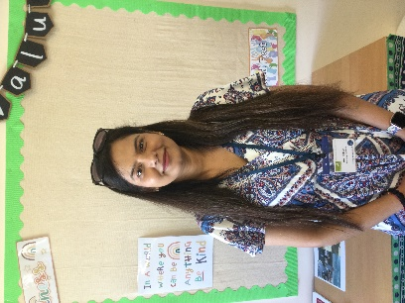
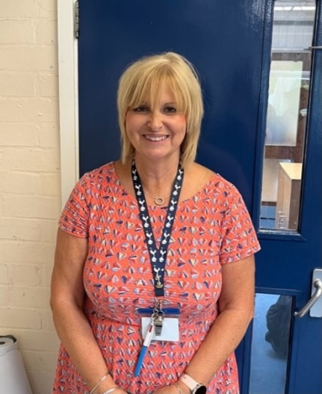

My name is Mrs Day and I work in Reception and Y1. I work Wednesdays, Thursdays and Fridays. I also work in breakfast club so you will see me around a lot!
My name is Miss Holland and I work in different year groups. I also work in breakfast and after school club.

My name is Mrs Bhatt and I work in Reception and Nursery. I work every day so I will see you regularly.

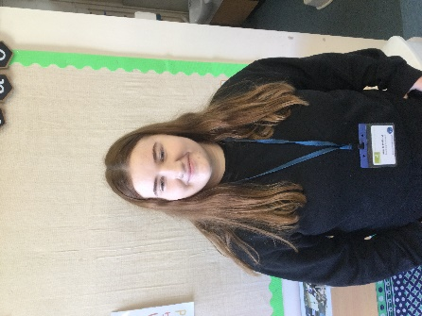

Our learning
This half term we will be thinking about the people who are special and important to us. We will be learning about our new classroom, getting to know the routines, making new friends and talking about our interests. We will be reading the story of ‘The Colour Monster goes to school’ before moving on to the ‘Three Little Pigs.’ We will be learning about our local area and looking at our homes. Please email in a photo of where you live so we can look at these in class.
Reading and Phonics
We will be teaching the children to read via our phonics programme, Little Wandle Letters and Sounds Revised. More information will be provided in the coming weeks.
Reading Books
To begin with, your child will be given a sharing story for you to read to them and with them at home. This book is purely for enjoyment, to talk about the pictures and to discuss the story. Your child is not expected to read this to you, but you may decide to act out the story after you have read it a few times! This will be changed once a week.
Over the coming weeks, phonics books will be provided for your child to read to you at home. These books will contain sounds that we have covered in class and the children are confident with. This will give your child the opportunity to ‘show off’ to you! Use the reading record that will be provided to write a comment about their reading and sounding out. Please ask your child to read little but often; every evening is preferable but please ensure this works around your busy schedules. Please ensure that your child’s reading book and reading record is in their book bag everyday as they may be listened to by a variety of adults throughout the week.
News Sharing
We don’t have a specific ‘show and tell’ session but every Monday morning we have ‘News Sharing’ in where children are invited to share any news they have. It is great if the children have a leaflet, photo or picture of somewhere they may have visited or something they may have done to support these discussions. No toys please.
Please send photos into our class email as often as you like. It is great for the children to stand up in front of the class and practise their speaking skills.
rec@colneyheath.herts.sch.uk
Other information:
Outside
We go outside in the Foundation Stage whatever the weather! Please ensure that your child has appropriate footwear (no open toe sandals, wellies on rainy days etc). Please leave a named pair or wellies in the cloakroom. Please could sun cream be applied at home and ensure that your child has a sun hat on sunny days and a coat if the weather is cold.

Children’s belongings
Can you please ensure that EVERYTHING is labelled, to minimise the chance of things being lost. Please can all children also have a named water bottle in class every day. Is it also preferable that your child has a blue school book bag instead of a rucksack, as these are easier to store in the classroom and hand out at home time.
Beginning of Each Day
Could we please ask parents and carers to hand all your child’s belongings to them by the gate in the morning. They should be lined up and at 8:55 they will be encouraged them to come inside the classroom by themselves. They are off to a great start with this!
Donations
Alongside the school fruit for snack we also like to offer another snack such as crackers, toast, breadsticks etc, and we ask for a small, voluntary contribution of around 50p a week. Thank you to those who have already provided a contribution, it is hugely appreciated. Your support also enables us to do extra activities such as baking, tasting different food, growing etc. during small group time. Please can any donations be handed to one of the Reception class staff. Thank you. Please also ensure that you have advised the school office of any allergies your child may have.

SAVE THE DATE!! – On Friday 8th November at 9am the Reception children will WOW you with all of their learning in their very first class assembly of the year! Don’t miss it!

