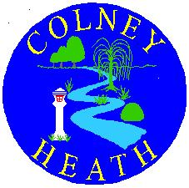

COLNEY HEATH SCHOOL & NURSERY

High Street, Colney Heath, St. Albans, Herts, AL4 0NP

Telephone: 01727 823898

E-mail: admin@colneyheath.herts.sch.uk

Website: www.colneyheath.herts.sch.uk

Headteacher: Mrs A Clark

21st March 2025

Dear Parents/Carers

Cookery Club
Year 1 & Year 2 – Miss Dockrell
Years 3 to 6 – Mrs Clark

We are very pleased to be continuing Cookery Club when we return after Easter.

The club will run on Wednesdays from 3:15pm to 4:15pm. It will run as a half term course, with children enjoying sessions in how to prepare healthy snacks and food. The first will start on Wednesday 30th April 2025 until Wednesday 21st May 2025. If your child wishes to join you must book a place and pay via School Gateway, children can only attend once this has been completed.

Places are limited and the payment will open on Gateway tomorrow.

The cost of the course will be £5 per child, per week (total £20) to cover staffing costs and the cost of ingredients.

Each week the children will prepare tasty, healthy snacks that they will then bring home to enjoy with their family. All recipes will be available with vegetarian alternatives, please let us know about any allergies your child may have. Children must have with them a container to bring home their results. Please be aware that dishes are prepared but if cooking is required this will need to be completed at home.

Thank you.

Yours sincerely

Mrs A Clark
Head Teacher

