Dear Year 1 Parents and Carers,
Happy New year to you all.
In Literacy we are continuing to work on our joined handwriting and finding out about conjunctions, adjectives, verbs and using these to create interesting sentences. We will be reading a variety of exciting books, nonfiction, poetry and fiction in our written work.
In Maths we will be continuing with Tens and Ones and will go on to working on measures of height and mass, using standard and non standard units . We will be adding using “ Think 10 “, comparing difference using language such as fewer and more than. We will be covering these in our daily maths and fluency lessons.
In Geography we will be looking finding out about “Climate” Primarily we will learn about the climate in the UK and then find out what the climate is like in the Antarctic and in the Desert. We will be finding out what animals and plant life live there.
In D and T We will be working on food preparation and learning cutting skills, we will design our own kabab using a variety of fruit.
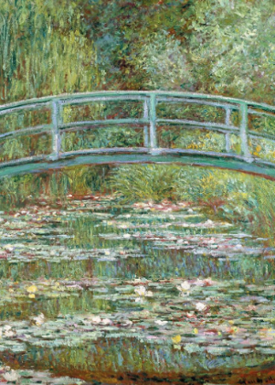
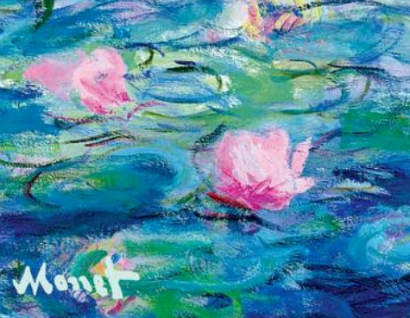
In Art we are going to look at the life and work of French Artist Claude Monet. We will focus on painting using watercolours with water based paints to create a variety of paintings including Monet`s water lilies.
In Music we will be following our scheme called Charanga and listen to a variety of different songs which we will find the pulse of. We will learn the songs “In the Groove “ and go on to learn “Round and Round “ we will also continue to learn to play the glockenspiel.
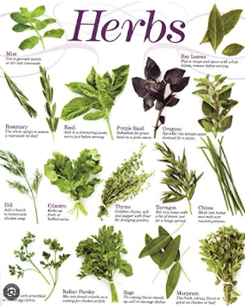
In PHSE we are following our scheme called Jigsaw. This term is all about “Dreams and Goals “ and moving on to “Healthy Me” in the second half of the term.
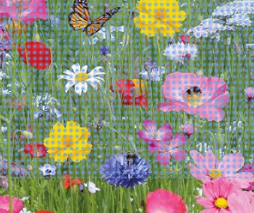
In Science we are starting to topic “Plants” where we will find out and label the parts of a plant and a tree and understand what job each part of the plant has. We will find out how to grow healthy cress inn an experiment and identify a variety of wild flowers and herbs.
In PE we will be using working on using a racket and developing our ball skills we will also be working on a unit of Gymnastics. PE lessons are on Tuesday and Friday. Pease ensure your child has a labelled PE kit in school. Thank you
In Computing we will be working on “Mazes” and “Animation” through the support of “Purple Mash.” I will post work for your children to enjoy at home.
In RE we will be finding out about “Belonging” to groups such as our school , our class , sports clubs, Rainbows and how it feels to belong. We will go on to learn about belonging to a Religion and find out about the Easter story.
In History our topic is “Explorers” we will be learning about Neil Armstrong and the first moon landing and Christopher Columbus who discovered South America.
Little Wandle Phonics Below are the phonics we will be learning this term. Please look at the sounds and go over them with your child.
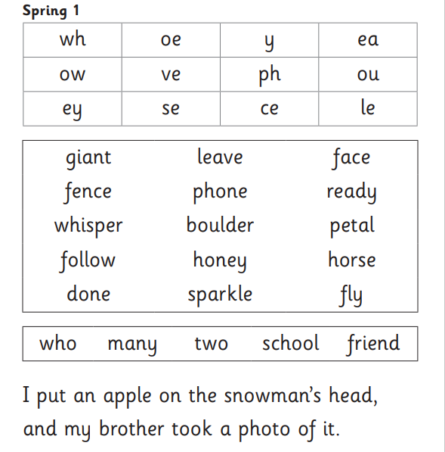
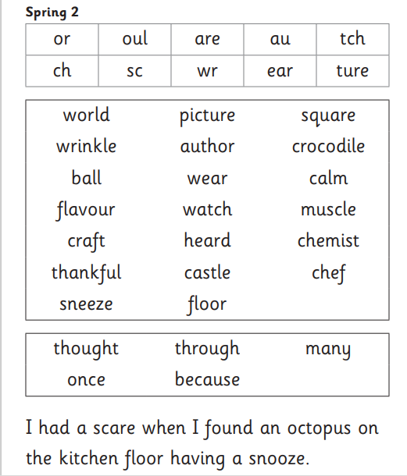

Thank you for your continued work in reading daily with your child it really does make and enormous difference their literacy progress.
Mrs Dowling

