September 2025 |  | Year Five  Class Newsletter |  |  |  |  |  | Autumn term
Miss Banerjee presents...  Our Learning Journey.  Autumn so far …  Year Five have very smoothly settled into their new routine and are making incredible changes every day. It is wonderful to see how hard working they are, and how supporting the families have been. I am very excited to see where their learning goes throughout this year.  - Miss Banerjee |  |  |  | 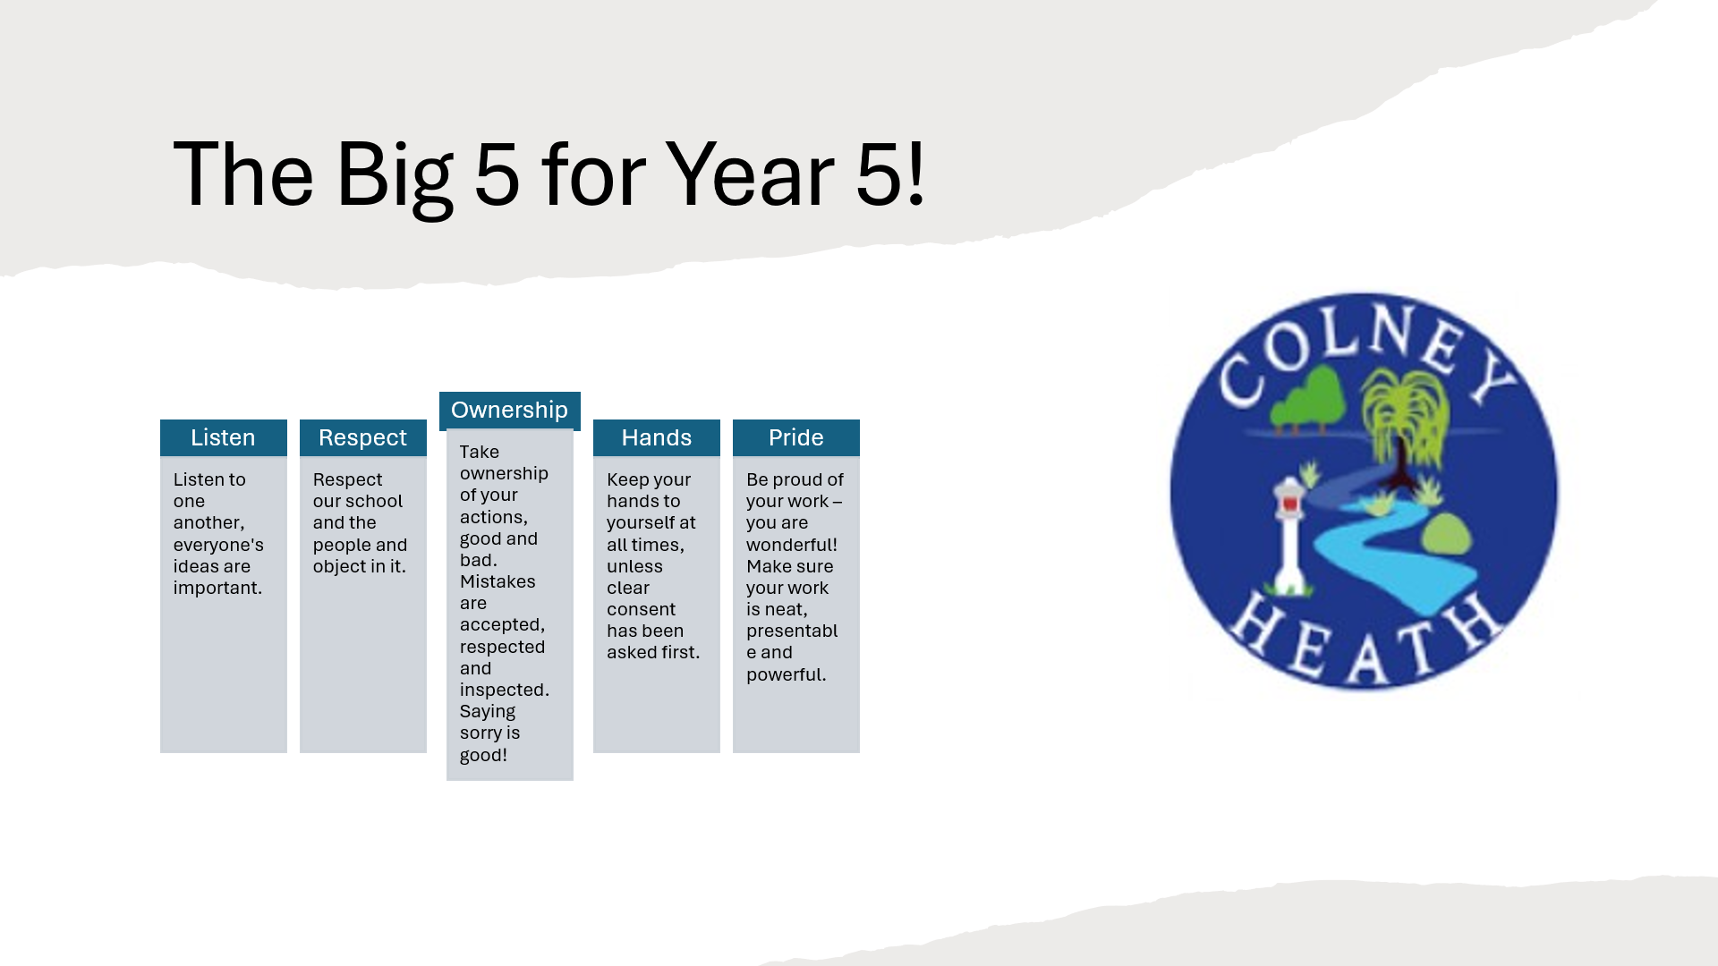
 |  |  |  | These are our classroom rules to ensure we are all safe, kind and happy!
Welcome to the Year 5 Team!
What can we do at home to help?
 |  |  |  | In Year Five it is important that we read at least four times a week. Year Five will be taking home a book from school that the child can read fluently and independently to an adult. I encourage adults to hear the child read aloud, as well as reading to themselves.  Children will also be learning our spellings daily as well as weekly Homework to support and continue their learning, starting with recapping their times tables. |  |  | During the year, children will get the chance to work with our lovely volunteers who will be supporting reading.  If anyone is interested in being a reading volunteer, please talk to Miss Banerjee!

Our adults are very impressed with our attitudes to Year Five so far.
Class assembly: Friday 10th October 2025
Class trip: Upcoming …

Mirjam Nilsson
 |  |  |  |  | Page 1

September 2025 | Autumn’s learning | Autumn term
What does learning look like in Year Five ?
Our learning journey is exciting!
English:
We are beginning our learning with book without words, The Tree and the River. Lots of our texts will help us to produce excellent writing, where we will be focusing on using commas correctly, as well as many other skills. We will be using relative clauses, complex sentences and learning how to reshape a sentence. We are also doing lots of work around enhancing our writing through the use of metaphors, personification, onomatopoeia, as well as using punctuation like dashes, colons and brackets for parenthesis. If you struggle to find a love for reading at home, because of work or time or any commitments, please speak with me and we can work together on this.
Science:
In Autumn, we will begin science by looking at all things Earth and Space. We will be able to discuss our solar system and the things you may find in it. We will discover how gravity works and planets, stars and eclipses.
Art and Design & Technology:
Art will begin by focusing on drawing. The children will look at a variety of artists across the year and then have chances to recreate pieces in various styles.
Design & Technology begins in Autumn Two where we will be learning about textiles and combining different materials. I wonder what we will create...
Maths:
The first half of Autumn term, we will be focusing on becoming fluent with our numbers to one million. This begins with looking at the place value of digits, including rounding up and down. We will then go on to exploring decimal place value and how the decimal point works. Moving swiftly on, we will cover dividing by 10, 100 and 100, as well as multiplying and dividing mentally.
We will then be moving on to fractions and ordering them, as well as adding and subtracting them.
Please feel free to ask me for any guidance on supporting your child in Math’s as I am very aware that methods change, as do teaching styles and so on, so feel free to reach out for some support!
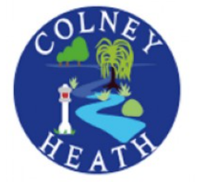

Geography: We are learning about the counties within our country and discussing the human and physical geographical features of the counties.
Computing:
The first thing we will cover in computing is online safety. This includes how to be safe online and keep ourselves and our personal information safe. The internet is very useful but it can also be dangerous so we have to be aware!
Religious Education:
We will start the year by looking at celebrations, symbols and incarnation within Christianity and Judaism.

What does learning look like in Year Five ?
Our learning journey is exciting!
Book changing:
Children’s books will be changed as and when they finish the book, so they are in charge of this. Reading books should be brought in every day. Please ensure adults write in reading records when the child has read at home, this will be checked daily. The expectation is to read at least four times a week as homework. Children will also read in school with a mixture of adults.
PSHCE:
In Year Five we will be starting by looking at ‘Being me in My World’. This topic covers welcoming others, making our school community a better place and working well with other people. This is going to be a very beneficial topic for our class because we will learn skills to ensure we are all being good friends to one another. We will also be discussing lots of topics, from personal space and how to play safely with friends, to how to identify a good friend and how to stay safe in public.
On top of this, children will be given the opportunity to express their feelings in a safe environment too. Children learn to trust and identify their safe adults in and out of school, as well as beginning to understand and verbalize their own feelings too.

Music:
We will be following a scheme called Charanga that will take us dancing and singing all the way across multiple music genres and musical skills, accessing lots of different instruments and songs. Look out for some of these skills in our class assembly!
Mystery reader:
I will be looking for volunteers for our mystery reader scheme. To volunteer to take part, please email.
PE:
Our PE days will be Mondays and Thursdays. Please ensure your child’s PE kit is labelled/named and in an appropriate bag to keep it safe. We come to school in uniform and we get changed in to our PE kit in school for the lesson. In winter, layers in black or navy are welcome to keep warm as we will be doing PE outside in various weathers. Gloves and hats also allowed.
In summer, please provide your child with a sun hat.
Getting in touch Year 5:
Email: yr5@colneyheath.herts.sch.uk
Emails will be checked daily and aim to reply within 48 hours, except over the weekend.
To arrange a phone call, please email to do so. For anything urgent, please call the office directly.
I am always happy to discuss any matter or concern, please just reach out. Don’t forget, home life is part of the Year Five Teaching Team too!
PPA time:
On a Tuesday afternoon, Year Five will be taught by Mrs Freislich for French and History. She will be maintaining high expectations of the class throughout this time and information regarding behaviour and work will be fed back to Miss Banerjee after every session.

Reward systems: Children in Year Five can earn house points for anything that is considered ‘above and beyond what is expected of them’.

